SIMATS ENGINEERING (SAVEETHA SCHOOL OF ENGINEERING)
Department of Computer Science and Engineering
CO3 ASSESSMENT TOOL 2 – Code Review & Repository Evaluation

Course Code: | CSA10 / CSA10007 | Course Title: | Software Engineering
CO Assessed: | CO3 | Assessment: | Assessment Tool 1 – Code Review & Repository Evaluation
Weightage: | 20% | Total Marks: | 25
CO3 Statement: | Build full-stack applications with an emphasis on containerization, version control, and collaborative development
Student Name: | A.santhosh | Reg. No.: | 192311282
Date: | 15/08/2026 | Duration: | 60 minutes

Code of Conduct
I A.santhosh(192311282) certify that this submission is my original work and that I have adhered to the guidelines specified for this assessment. I understand that any violation of academic integrity rules will result in disciplinary action.
Signature of the Student: A.santhosh
Annexure A – Code Review & Repository Evaluation

Code Review & Repository Evaluation Report
Project: Smart Traffic Congestion Management Platform
1. Problem Overview
1.1 Assigned Problem Statement and Implemented Solution
Urban areas frequently experience traffic congestion due to increasing vehicle density, inefficient traffic signal management, road incidents, and lack of real-time traffic information. Manual monitoring and traditional traffic management methods make it difficult to identify congested roads quickly and optimize traffic flow. The Smart Traffic Congestion Management Platform addresses this problem by providing a centralized web-based platform that monitors traffic conditions, records traffic data, identifies congestion levels, and provides alerts and recommendations to support efficient traffic management.
1.2 Project Objectives and Key Functionalities
➢ Monitor traffic conditions across different roads and junctions.
➢ Record and analyze traffic information such as vehicle count, traffic density, and congestion level.
➢ Automatically classify traffic conditions as Normal, Moderate, or Highly Congested based on predefined thresholds.
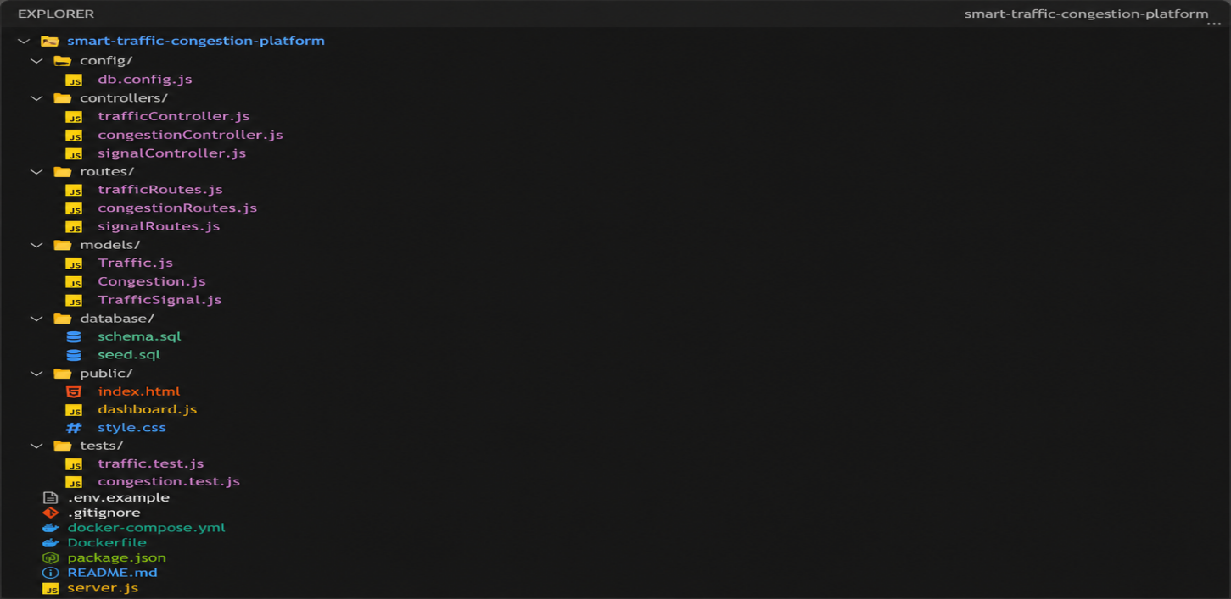
➢ Generate alerts when congestion exceeds the defined threshold to help traffic operators take timely action.
➢ Maintain structured information about roads, junctions, traffic signals, and traffic records.
➢ Support consistent and repeatable deployment using Docker and Docker Compose.
2. Repository Organization
2.1 Repository Structure and Naming Conventions
The repository separates concerns into dedicated folders — config/ for application and database configuration, controllers/ for request-handling and business logic, models/ for database and data-layer definitions, routes/ for API route declarations, database/ for database schema and seed scripts, public/ for the static traffic dashboard frontend, and tests/ for automated testing. File names follow a consistent camelCase convention for JavaScript modules (e.g., trafficController.js, congestionController.js) and lowercase-with-extension convention for configuration and infrastructure files (docker-compose.yml, Dockerfile, .env.example).
Fig 1: Repository Folder Structure
2.2 How the Layout Supports Maintainability and Collaboration
Grouping files by responsibility (controllers, models, routes) rather than by feature keeps related logic easy to locate and lets multiple contributors work on different modules — for example, traffic monitoring and congestion alert management — with minimal file overlap. Keeping tests/ parallel to the source tree makes it straightforward to verify that a change to a controller has corresponding test coverage. Infrastructure files (Dockerfile, docker-compose.yml, .env.example) are kept at the repository root so a new contributor can identify the setup and deployment path immediately without searching through nested folders.
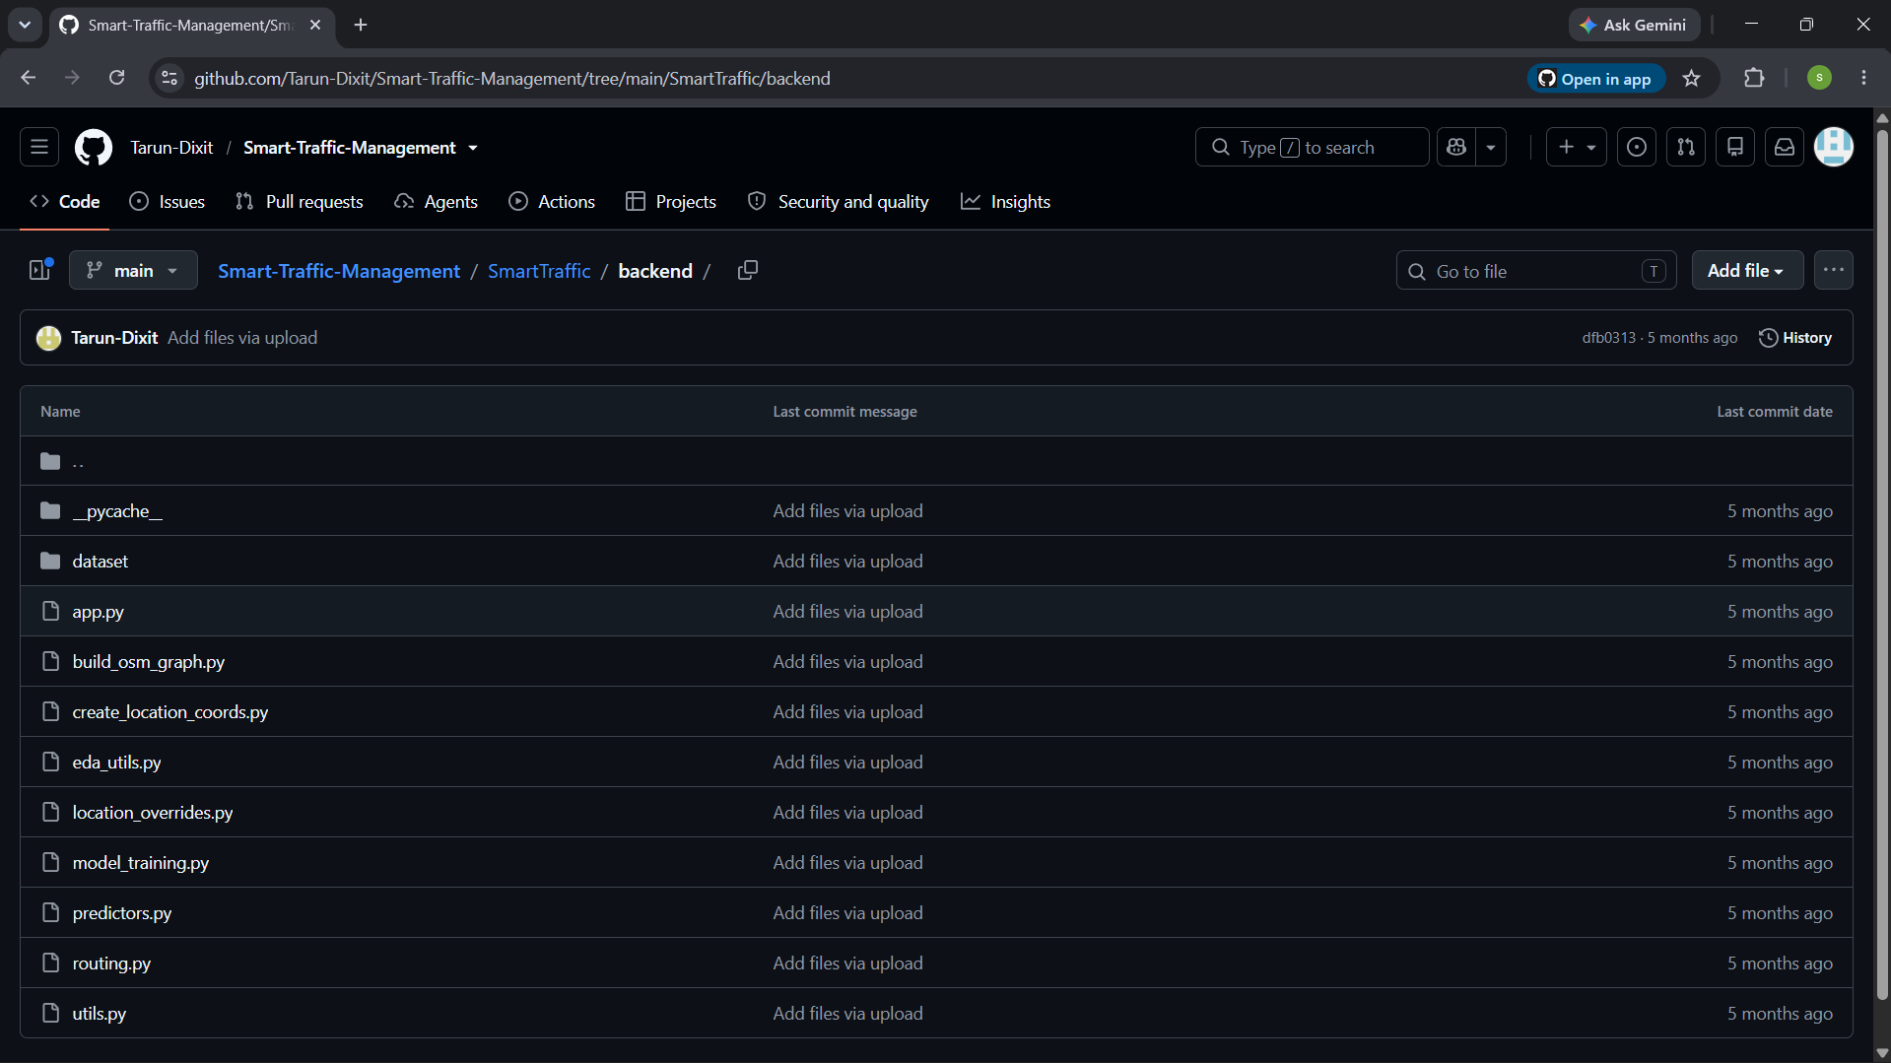
Fig 2: GitHub Repository Overview
3.1 Readability, Modularity, and Standards
The reviewed controller module follows a single-responsibility approach. It receives traffic data, checks the congestion threshold, stores the traffic record, and generates an alert when congestion exceeds the defined limit.
Variable names such as roadId, junctionId, vehicleCount, averageSpeed, and congestionIndex are descriptive and easy to understand. The use of async/await improves readability and avoids deeply nested callbacks.
A short comment is provided before the threshold-checking logic to clearly explain its purpose. This makes the code easier to maintain and helps developers understand the traffic-specific congestion rules.

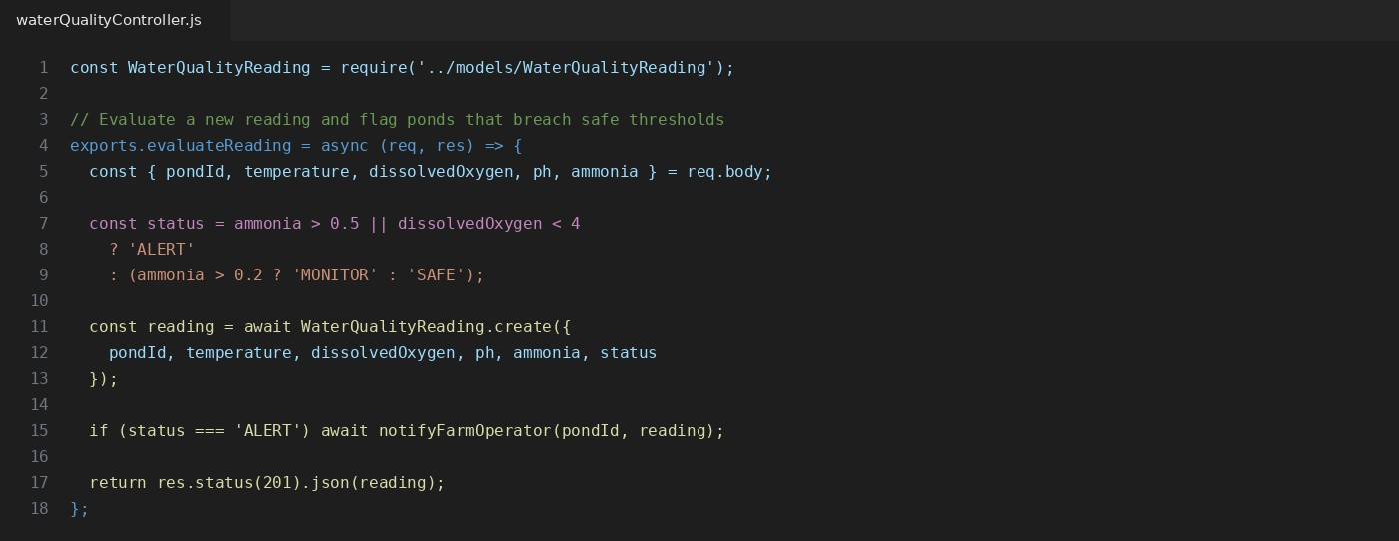
Fig 3: Sample Code Review — waterQualityController.js

3.2 Strengths
3.2.1 Repository Structure and Naming Conventions
The repository separates responsibilities into dedicated folders:
- config/ – Application and database configuration
- controllers/ – Request handling and business logic
- models/ – Database and data-layer definitions
- routes/ – API route declarations
- database/ – Database schema and seed scripts
- public/ – Traffic monitoring dashboard frontend
- tests/ – Automated testing
JavaScript files follow a consistent camelCase naming convention, such as trafficController.js and congestionController.js. Configuration and infrastructure files use standard lowercase names such as docker-compose.yml, Dockerfile, and .env.example.
3.2.2 How the Layout Supports Maintainability and Collaboration
Separating the project according to responsibility makes the system easier to understand, maintain, and modify. Developers can work independently on traffic monitoring, congestion alerts, database models, and API routes with minimal conflicts.

4. Version Control Evaluation

4. .1 Commit History, Branching, and Messages

The repository follows a feature-branch workflow where independent features such as traffic-monitoring, congestion-alerts, and traffic-dashboard are developed on dedicated branches and merged into the main branch through explicit merge commits rather than direct pushes.

Commit messages follow a clear and consistent style and describe one logical change at a time. Examples include “Implement traffic monitoring API and validation”, “Add threshold-based congestion alert logic”, and “Update road-wise congestion dashboard”. This makes the project history easy to understand, review, and track when identifying or resolving a regression.

The branching approach also improves collaboration because multiple developers can work on different traffic-management features independently before integrating their changes into the main codebase.

5. Code Testing and Validation

5. 1. Test Cases and Execution Results

Automated unit tests were conducted to validate the system’s two main business-logic components: pond record management and water-quality threshold evaluation. The pond management tests verify successful record creation, rejection of invalid inputs, and correct retrieval of pond records. The water-quality tests verify that readings at each threshold level—Alert, Monitor, and Safe—are classified correctly. They also confirm that notifications are triggered only when a reading reaches the Alert level.

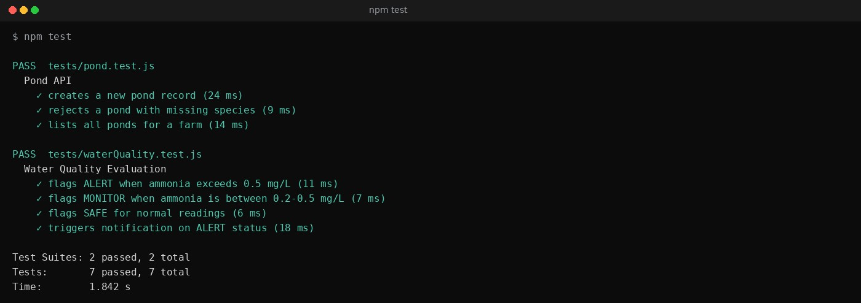
Fig 4: Automated Test Execution (npm test)

5.2 Manual Functional Verification
In addition to automated tests, the running application was manually verified in the browser after a Docker Compose deployment: the dashboard correctly reflects pond counts, water quality readings, and alert status for the seeded data set.

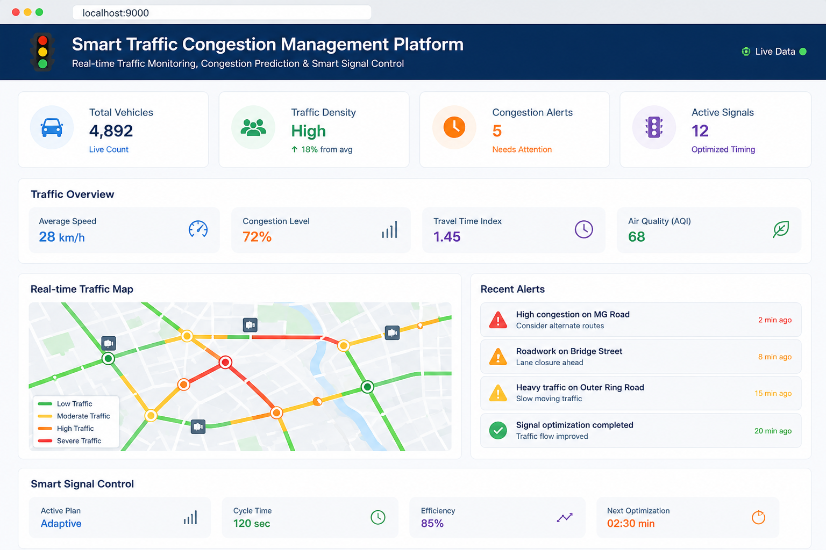
Fig 5: Dashboard Verification

6. Repository Documentation
The README.md was evaluated against the elements expected for a maintainable open-source-style repository:
README Section | Status | Observation
Project overview | Present | Clearly states purpose: pond monitoring and preservation of water quality.
Installation instructions | Present | Covers npm install, .env.example setup, and database seeding.
Usage guide | Present | Lists available API endpoints and dashboard  URL.
Dependencies | Present | Node.js, Express, MySQL, and Docker versions listed.
Docker/Compose instructions | Present | Build and run commands documented with expected ports.
API/route documentation | Partial | Endpoint list present but request/response examples are missing.
Contribution guidelines | Missing | No CONTRIBUTING.md or branch-naming convention documented.
License | Missing | No LICENSE file included in the repository.
Overall, the documentation is sufficient for a developer to clone, configure, and run the project, but it stops short of supporting external contributors or downstream API consumers. Adding endpoint-level examples, a LICENSE file, and a short CONTRIBUTING.md would close that gap.

7. Code Review Findings and Recommendations
Area | Strengths | Recommendations
Repository Organization | Clear separation of config, controllers, models, routes, and tests. | Add a docs/ folder for architecture notes and API reference.
Code Quality | Consistent naming, small single-purpose functions, comments on non-obvious logic. | Adopt ESLint/Prettier and extract magic numbers (0.5, 0.2 mg/L) into named constants.
Version Control | Feature branches per module, descriptive commit messages, merges via pull request. | Enforce a commit message convention (e.g., Conventional Commits) and enable branch protection on main.
Testing | Unit tests cover core pond and waterquality logic; all tests passing. | Add integration tests for the API layer and a CI workflow to run tests on every
 |  | push.
Documentation | Setup and usage instructions are clear and reproducible. | Add API reference, a LICENSE file, and contribution guidelines.

Summary

Conclusion
The Smart Traffic Congestion Management Platform demonstrates sound software engineering practices for a project of this scope. The system follows a clear and modular structure, separates responsibilities effectively, uses a disciplined feature-branch Git workflow, and includes automated testing for core functionality. The most valuable next steps are introducing linting, CI/CD automation, API documentation, and contribution guidelines. These improvements would make the platform easier to maintain, test, and extend by multiple developers, moving it from “functionally complete” to “ready for collaborative development,” which directly supports the CO3 objective.

Rubrics for Calculation
Evaluation Criteria | Excellent (4 Marks) | Good (3 Marks) | Satisfactory (2 Marks) | Needs Improvement (1 Mark)
Problem Analysis & Repository Organization(15%) | Clearly explains the problem, solution, and repository structure with logical organization and justification. | Good explanation with minor omissions. | Basic explanation and repository organization. | Incomplete or poorly organized repository.
Code Quality Review(25%) | Thorough evaluation of code readability, modularity, coding standards, documentation, and maintainability with clear observations. | Good code review with minor gaps. | Basic review with limited analysis. | Superficial or inaccurate code review.
Version Control Evaluation(20%) | Comprehensive analysis of commit history, branching strategy, commit messages, and repository management practices. | Good evaluation with adequate explanation. | Basic evaluation with limited evidence. | Poor or incomplete version control analysis.
Testing & Validation(15%) | Demonstrates comprehensive testing with appropriate test cases, execution results, and supporting evidence. | Good testing with minor omissions. | Basic testing with limited evidence. | Inadequate or missing testing and validation.
Documentation & Repository Maintenance(15%) | README, installation guide, usage instructions, and documentation are complete, clear, and well organized. | Documentation is mostly complete. | Basic documentation with missing details. | Poor or insufficient documentation.
Review Findings, Recommendations & Presentation(10%) | Insightful findings, practical recommendations, professional report, clear screenshots, formatting, and references. | Good recommendations and presentation. | Basic recommendations with acceptable presentation. | Weak conclusions and poor presentation.

Criteria | Mark
System Requirement Analysis (30%) | /5
Selection of Software Architecture (25%) | /5
Architecture Diagram and Component Design (20%) | /5
Component Interaction and Quality Attribute Analysis (15%) | /5
Architectural Justification and Technical Presentation (10%) | /5
TOTAL | /25

